Outlines

Sl.No. | Description | Page No.
2 | Introduction Banks are critical when it comes to the economy of any country. The global financial system is a kind of financial system comprising of regulators and institutions that function on global level, rather than regional level. Islamic bank is a typical type of this category. The banks has emerged to be one of the competitive and likely alternatives for the conventional banking during the last few decades. Islamic banking is no longer restricted to one geographical location as well as specialized institutions. It has also expanded in terms of products diversification, with well-organized credit finance which raises eyebrows. This system of banks are governed by the Islamic rules which are also applied in all Islamic economics. The philosophies that focuses on ethical and moral values when it comes to its all dealings  - Paper outline  - Research Questions: What are the main drivers of the Islamic banks toward profit making?  What are the specific objective of the banks in promoting the equity of shreholders?  - Research Methods and objective  To establish the effect of Islamic banking products on the financial performance | 3
3 | Literature Review Previous studies acted as an indicator to determine customers’ perception towards Islamic banking. For instance, Hassan (2007) studied customers’ perception towards Islamic banking in Pakistan. His study examined several important dimensions including knowledge, socio-religious context, Shariah compliances, and willingness to deal with Islamic banks, and quality and attractiveness of offerings. This study found a positive perception of all dimensions investigated with customers indicating overall high satisfaction towards products and services of Islamic banks as compared to conventional banks. Rashid, Hassan and Ahmad (2010) conducted a study on perception of customers towards domestic Islamic banks in Bangladesh. They examined six critical elements, namely corporate efficiency, compliance with Islamic rules, convenience, core banking, confidence, and cost benefit. This study found that customers are highly satisfied with corporate efficiency and compliance with Islamic rules as substantial factors for them to choose their intended service. In the case of Malaysia, Dusukiand Abdullah (2006) studied several critical reasons why Malaysian customers patronize Islamic banks and measured the elements of reputation, service delivery, product price, and social responsibility of Islamic banks. The study found that a combination of Islamic and financial reputation and service quality are the main patronage factors. | 4
4 | Data Collection  Data Collection For the performance of the Islamic bank to be test by use of the ROE scheme, The Data were then obtain from the main annual report that are of the Islamic bank that are located in different parts. This was done based on the rank of the total assets. The statement of the income that reflects the changes in the equity of the shareholders, then balance sheet, the notes of the financial statement and the statement that shows the cash flow.  The crucial issue in the part of analysis was the availability of the main data. Exclusion was then made on other banks that were operating on strictly Islamic financial areas since there statement would be biased and does not reflect the final results that were intended | 18
5 | Data Analysis  - Graphs & Charts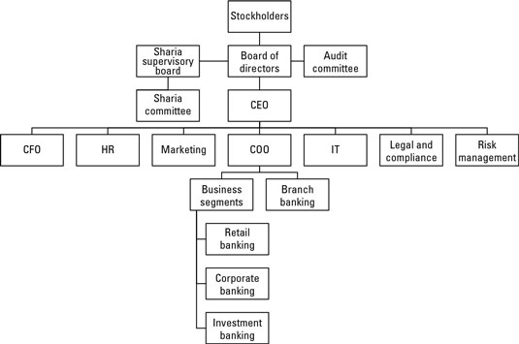  - 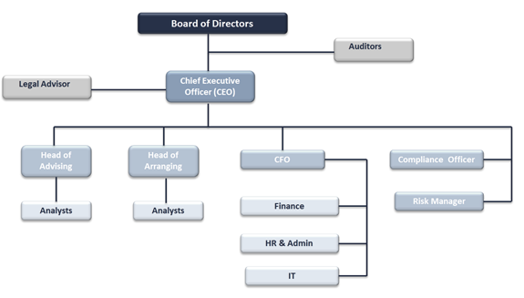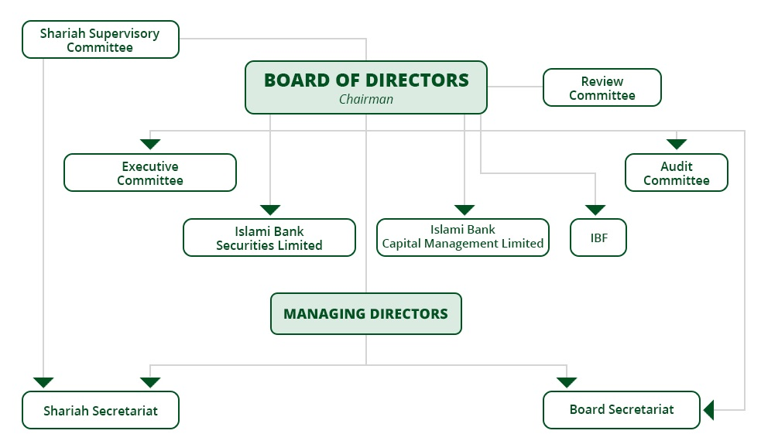b.Explanations  Islamic banking systems in these countries have a common thing. All of them have shariah supervisory committee whose main roles are to ensure the shariah rules and regulations are adhered to. This includes the principles of the Islamic bank such as sharing of profits as well as loses and the notion of lending out loans without interest rates. Like the conventional banks, the Islamic banks have board of directors who oversees all operations taking place in the bank. Additionally, the board of directors rules the bank by shaping policies and procedures. The organizational chat of countries like Afghanistan are structured when compared to that of countries such as Mauritius. This can be attributed to the year the banks was started, and other regional factors. | 20
6 | Conclusion Islamic banks has played a major role in its financial operations. The following areas should of key importance: evaluation of the procedures laid down for the tracking of shareholders equity troubles, ensuring that there are appropriate security policies in place for the data enabled Islamic bank and exist effective change management. | 22
7 | Bibliography Chong, B. S., & Liu, M. H. (2009). Islamic banking: interest-free or interest-based?. Pacific-Basin Finance Journal, 17(1), 125-144.  Gheeraert, L., & Weill, L. (2015). Does Islamic banking development favor macroeconomic efficiency? Evidence on the Islamic finance-growth nexus. Economic modelling, 47, 32-39.  Sairally, S. (2007). Community development financial institutions: Lessons in social banking for the Islamic financial industry. Kyoto Bulletin of Islamic Area Studies, 1(2), 19-37. | 23

Introduction:
This project Islamic banking structure has been started to understand the role, functioning in retail, corporate and investment services in Islamic banking in Islamic states (Afghanistan, Mauritius, Saudi Arabia and Yemen). The Islamic banking is actually based on Sharia principles and compliances established around 1400 years before in Holy Quran book. The sharia laws and compliances guidance had been inspired around with basic idea of sharing profit or loss, prohibition of interest based financial transactions and hedging .The Islamic banking system believes in establishing the business relationship for sharing both profit and loss between the parties.
The key features of Islamic banking is usage of UPSIA (Unrestricted profit sharing) and loss bearing) investment accounts is investment products that believes in sharing profit and loss proportionately as agreed before enter into the agreement. The UPSIA is not well recognized in many US and European countries where certain percentage of return had been fixed before making in investment decisions. The main characteristics of Islamic banking system is prohibition of Riba (interest which is excess or fix addition for any investment decisions) and making financing and investment decision in prohibited (haram) business like pork, alcohol and interest based financing business. (Algaoud, 2001). The spectacular expansion of Islamic banking and investment products in US, European and Asian countries attract many investors and bankers to adopt Islamic banking products and services for getting continuous positive return on investments. Malaysia, Indonesia, UAE, Morocco and specially Saudi Arabia are few countries shows continuous growth in investment returns on the schemes that are allowed under sharia compliance acts. Currently they are more than 33 government run banks, 40 private banks and 71 Islamic investment companies operating all around the globe.
Research Questions:
1) Is Islamic banking is successful in Islamic States
2) Is Islamic banks governs by country laws and regulations
3) Is there is any risk in Islamic banking system
Research methodology:
This research project about Islamic banking functioning in Saudi Arabia had been initiated for gathering information’s from various sources by visiting banks, financial institutions, investment companies and talking to faculty members and general public. The Islamic banking system in Saudi Arabia is very selective and special privilege subject that needs clear and deeper understanding about these banking system real functions and its future prospects in Saudi Arabian markets and around the world financial markets. Doing the literature review through the library, journals, books, and Internet.

Part II:
- Islamic banking literature review
Previous studies acted as an indicator to determine customers’ perception towards Islamic banking. For instance, Hassan (2007) studied customers’ perception towards Islamic banking in Pakistan. His study examined several important dimensions including knowledge, socio-religious context, Shariah compliances, and willingness to deal with Islamic banks, and quality and attractiveness of offerings. This study found a positive perception of all dimensions investigated with customers indicating overall high satisfaction towards products and services of Islamic banks as compared to conventional banks. Rashid, Hassan and Ahmad (2010) conducted a study on perception of customers towards domestic Islamic banks in Bangladesh. They examined six critical elements, namely corporate efficiency, compliance with Islamic rules, convenience, core banking, confidence, and cost benefit. This study found that customers are highly satisfied with corporate efficiency and compliance with Islamic rules as substantial factors for them to choose their intended service. In the case of Malaysia, Dusukiand Abdullah (2006) studied several critical reasons why Malaysian customers patronize Islamic banks and measured the elements of reputation, service delivery, product price, and social responsibility of Islamic banks. The study found that a combination of Islamic and financial reputation and service quality are the main patronage factors.

Part III
Data Collection
For the performance of the Islamic bank to be test by use of the ROE scheme, The Data were then obtain from the main annual report that are of the Islamic bank that are located in different parts. This was done based on the rank of the total assets. The statement of the income that reflects the changes in the equity of the shareholders, then balance sheet, the notes of the financial statement and the statement that shows the cash flow.
The crucial issue in the part of analysis was the availability of the main data. Exclusion was then made on other banks that were operating on strictly Islamic financial areas since there statement would be biased and does not reflect the final results that were intended

Part IV :
Data analysis
Data can be interpreted in a number of ways. Common techniques of analyzing data comprises common size analysis, ratio analysis, trend analysis, cross-sectional analysis as well as regression analysis.
Composition of an Islamic bank’s assets in a 2009

Conclusion:
The study Islamic banking structure covers the various practices, structures and setup exists in different Islamic states. Islamic banking are here to stay for long period of time and can become very competitive for traditional existing commercial banking norms and procedures. Even though there is lot of competition from commercial banking industry where interest based personal, retail, commercial and treasury functions are carried out with viable and referable economic benefits. However, Islamic banking had some very innovative products and ideas that transform the banking industry in different parts of the world. The country like Saudi Arabia had achieved economic growth through application of Islamic banking system only. This trade and practices are carried out in local Islamic banks are become the guide for other banks to follow. The countries like Afghanistan, Mauritius and Yemen are successfully following the norms; procedures and regulations of Sharia based Islamic bank functions are achieving tremendous growth and benefits.
Even though, the Islamic banking system are progressing with complacent pace, still there is lot of people willing to participate on the religious background basis for depositing their money just for not getting interest on their deposits. Therefore there is tremendous scope for Islamic banking and finance products and services to prosper not Muslim countries but also in other parts of the world.

Islamic banks has played a major role in its financial operations. The following areas should of key importance: evaluation of the procedures laid down for the tracking of shareholders equity troubles, ensuring that there are appropriate security policies in place for the data enabled Islamic bank and exist effective change management.

